**Project Report**

**iRevolution: A Data-driven Exploration of Apple's iPhone Impact in India**

|  |  |  |
| --- | --- | --- |
| **Student Name** | **Team** | **Student NM id** |
| VISHVA A | Team Leader | 2EDEAE8D3ADAA128D2E4DC84D72FEE9D |
| T.RAGULKUMAR | Team Member | 9224B5534C234369C1E4AA5EE1D0CF4B |
| M.SHEKABDUL KADAR | Team Member | 5BA0D48541547CBBA9645D80E6358201 |

**Content:**

1. **Introduction**
   1. **Overview**
   2. **Purpose**
2. **Problem Definition & Design Thinking**

**2.1 Empathy Map**

**2.2 Brainstroming Map**

**3. Result**

**4. Advantages & Disadvantages**

**5. Applications**

**6. Conclusion**

**7. Future Scope**

**8. Appendix**

**Project Report**

**iRevolution: A Data-driven Exploration of Apple's iPhone Impact in India**

1. Introduction

Apple formerly Apple Computer, Inc., is a multinational corporation that creates consumer electronics, personal computers, servers, and computer software, and is a digital distributor of media content. The company also has a chain of retail stores known as Apple Stores. Apple's core product lines are the iPhone smartphone, iPad tablet computer, and Macintosh computer line. Founders Steve Jobs and Steve Wozniak created Apple Computer on April 1, 1976, and incorporated the company on January 3, 1977, in Cupertino, California.

Current Apple Inc. logo, introduced in 1998, discontinued in 2000, and re-established in 2014

For more than three decades, Apple Computer was predominantly a manufacturer of personal

computers, including the Apple II, Macintosh, and Power Mac lines, but it faced rocky sales

and low market share during the 1990s. Jobs, who had been ousted from the company in 1985, returned to Apple in 1997 after his company NeXT was bought by Apple. The following year he became the company's interim CEO which later became permanent Jobs subsequently instilled a new corporate philosophy of recognizable products and simple design, starting with the original iMac in 1998. With the introduction of the successful iPod music player in 2001 and iTunes Music Store in 2003, Apple established itself as a leader in the consumer electronics and media sales industries, leading it to drop "Computer" from the company's name in 2007. The company is now also known for its iOS range of smart phone, media player, and tablet computer products that began with the iPhone, followed by the iPod Touch and then iPad. As of June 30, 2015, Apple was the largest publicly traded corporation in the world by market capitalization with an estimated value of US$1 trillion as of August 2, 2018 Apple's worldwide annual revenue in 2010 totalled US$65 billion, growing to US$127.8 billion in 2011 and $156 billion in 2012. The first Apple Stores were originally opened as two locations in May 2001 by then-CEO Steve Jobs, after years of attempting but failing store-within-a-store concepts. Seeing a need for improved retail presentation of the company's products, he began an effort in 1997 to revamp the retail program to get an improved relationship with consumers and hired Ron Johnson in 2000. Jobs re-launched Apple's online store in 1997 and opened the first two physical stores in 2001. The media initially speculated that Apple would fail, but its stores were highly successful, by passing the sales numbers of competing for nearby stores and within three years reached US$1 billion in annual sales, becoming the fastest retailer in history to do so. Over the years, Apple has expanded the number of retail locations and its geographical coverage, with 511 stores across 25 countries worldwide as of May 27, 2021, when the new flagship store at Via del Corso in Rome opened Strong product sales have placed Apple among the top-tier retail stores, with sales over $16 billion globally in 2011. In May 2016, Angela Arendt’s, Apple's then-Senior Vice President of retail, unveiled a significantly redesigned Apple Store in Union Square, San Francisco, featuring large glass doors for the entry, open spaces, and rebranded rooms. In addition to purchasing products, consumers can get advice and help from "Creative Pros" – individuals with specialized knowledge of creative arts; get product support in a tree-lined Genius Grove; and attend sessions, conferences, and community events, with Ahrendts commenting that the goal is to make Apple Stores into "town squares", a place where people naturally meet up and spend time. The new design will be applied to all Apple Stores worldwide, a process that has seen stores temporarily relocate or close. Many Apple Stores are located inside shopping malls, but Apple has built several standalone flagship stores in high-profile locations. It has been granted design patents and received architectural awards for its stores' designs and construction, specifically for its use of glass staircases and cubes. The success of Apple Stores has had significant influence over other consumer electronics retailers, who have lost traffic, control and profits due to perceived higher quality of service and products at Apple Stores. Apple's notable brand loyalty among consumers causes long lines of hundreds of people at new Apple Store openings or product releases. Due to the popularity of the brand, Apple receives many job applications, many of which come from young workers. Apple Store employees receive above-average pay, are offered money toward education and health care, and receive product discounts; however, there are limited or no paths of career advancement. A May 2016 report with an anonymous retail employee highlighted a hostile work environment with harassment from customers, intense internal criticism, and a lack of significant bonuses for securing major business contracts.

* 1. **Overview**

The world has changed as a consequence of the increasing use of smartphones, which have improved communication, connected people, and revolutionized many different businesses. With its main product, the iPhone, capturing markets around the world, Apple Inc. has emerged as a prominent player among the top smartphone makers. India, one of the economies with the greatest economic growth, has seen a tremendous increase in smartphone usage, making it an interesting market to study the effects of Apple's iPhone. In order to shed light on important factors like market penetration, customer preferences, economic ramifications, and societal changes, this research report will perform a data-driven investigation of the impact of the iPhone in India. This study will offer invaluable insights into the transformative impact of the iPhone on India's technological landscape and the lives of its consumers by using advanced data analytics techniques and analyzing large datasets. Apple has a special chance to increase its market share and develop a significant presence in India thanks to the country's large population and rising smartphone adoption. Each new iPhone model unveiling generates excitement and anticipation among Indian buyers. By utilizing the plethora of information. Already accessible, this research aims to go beyond conjecture and anecdotal evidence in order to develop a thorough knowledge of the effects of the iPhone.

## IMPACTS OF IPHONES ON THE SOCIETY

### IMPACT 1:

Apple’s iPhone was a great success because it made communication more convenient than ever before. It allowed people to access information through digital media on their phones. Apple’s iPhone is an amazing invention that allows users to get all of their needs done in one device. Apple’s iPhones are not only used for entertainment purposes but they can be used for business purposes. All these tasks can be performed with ease by using the apps available on the App Store. For instance, you can use your iPhone to browse the internet, check emails, make calls, track flights, pay bills, watch videos and movies, listen to music, create presentations, write documents and share pictures. With a smartwatch or fitness band, you will never have to worry if your iPhone battery dies while watching movies or playing games.

### IMPACT 2:

Social Media Apps like Instagram, Snapchat, LinkedIn etc…have been created. This revolutionized social interactions and made people want to connect. With the help of social media, people became connected from all over the world. They could share the news with family, friends and colleagues; find jobs, and discover new places.

### IMPACT3:

iPhones also helps people in society to relieve stress by playing [gambling online](https://www.casinoranking.lv/) games. There are many sites where one can easily play free slots, poker and blackjack. People would just need to download the app and go to the site. One can win big cash prizes every day!

iPhones have transformed the way we do things in life. iPhone users are now able to perform several activities without having to step out of their homes. The impact of iPhones on society is undeniable.

* 1. **Purpose**

The purpose of this project is to visualize the impact of Apple iPhone in India.

How has the iPhone impacted the way we live our lives? This question has puzzled us since its release. The smartphone revolution changed the way we communicate, shop, play [online blackjack](https://www.rivernilecasino.com/online-blackjack/) games, work and even entertain ourselves. This phone is also known to give rise to new industries and businesses. In the past decade, technological advancements in the smartphone sector have led to the growth of innovative companies such as Uber, Netflix, Instagram, YouTube, and Facebook.

The second part of the strategy is to build Apple products in the country, a massive project that requires not only Apple’s attention, but also efforts from its manufacturing partners and local and national governments.

Nearly all iPhones are currently assembled in China, which has caused some problems over the past five years, starting with trade tensions and [possible tariffs](https://www.cnbc.com/2019/12/13/apple-dodges-iphone-tariff-after-trump-confirms-china-trade-agreement.html) during the Trump administration, and extending to more recent supply chain disruptions caused by Covid and China’s Covid policies, [which led to sales shortfalls](https://www.cnbc.com/2022/11/06/apple-warns-covid-restrictions-in-china-are-hurting-iphone-production-.html).

India could end up being a big winner as Apple looks for non-Chinese manufacturing options. In January, India’s commerce minister told CNBC that Apple was manufacturing its latest iPhone 14 in the country and had a goal to produce as many [as 25% of all iPhones](https://www.cnbc.com/2023/01/23/apple-looking-to-boost-iphone-production-in-india-to-25percent-minister.html) in the country.

Apple’s primary manufacturing partner, Foxconn, which oversees a large portion of the assembly of new iPhones in China, is expanding in India, too, [reportedly](https://www.cnbc.com/2023/03/03/iphone-supplier-to-build-factory-in-india-a-further-pivot-from-china-report.html) building a $700 million plant for iPhone parts in Bangalore.

In another parallel to China, the Indian government is eager to embrace Apple and use it as a symbol to attract other high tech firms to the country for manufacturing and development. Over the past 20 years, Chinese governments at multiple levels have [worked](https://www.nytimes.com/2016/12/29/technology/apple-iphone-china-foxconn.html) to make massive factories like Foxconn’s Zhengzhou factory — known as “iPhone City” — possible.

Modi wants to discuss Apple’s plans for manufacturing around the country and creating manufacturing jobs, [CNBC’s Seema Mody reported](https://www.cnbc.com/2023/04/18/apple-ceo-tim-cook-plans-to-meet-with-modi-on-wednesday-in-new-delhi.html). He also wants to know about the challenges Apple has faced in growing its user base in the country.

This isn’t the first time that investors have been excited about Apple’s potential in India, and some analysts warn that it may take a while before it becomes a huge market.

“I’ve told investors this: All the all the hype you’re hearing about India this week is great,” Zino said. “I mean, it is a massive opportunity in our view, over the next decade, but don’t expect things to change overnight.”

Apple has also faced challenges in its early experiments manufacturing in the country, most notably at a Wistron factory in Bengalaru assembling older model iPhones, which [erupted in a labor riot](https://www.reuters.com/article/us-apple-india-wistron/apple-supplier-wistron-to-restart-india-factory-still-on-probation-idUSKBN2A90PU) in late 2020.

**Problem Definition & Design Thinking**

**2.1 Empathy map**

An empathy map is a template that organizes a user’s behaviors and feelings to create a sense of empathy between the user and your team.

The empathy map represents a principal user and helps teams understand their motivations, concerns, and experience.

Empathy mapping is a simple yet effective [workshop](https://frescopad.com/virtual-workshop-definition/) that can be conducted with various users in mind, anywhere from stakeholders, individual use cases, or entire teams of people. Many teams, such as design teams, sales, product development, and customer service, can conduct it.

Essentially, an empathy mapping exercise is a practice that seeks to get inside the head of the customer as they interact with your product/service.

While the main importance of an empathy map is creating empathy between you and the user, some other important facets of using one offer different benefits to your team. Creating an empathy map considers many factors in relation to the customer’s overall experience.

These could be the problems they handle, how they use the product/service within a larger team, and who experience the brunt of the problem.

These details are essential to creating a holistic view of their experience because they illuminate the problem in your team’s mind. This is equally as important and helps build an overall understanding of how users interact with your product/service.

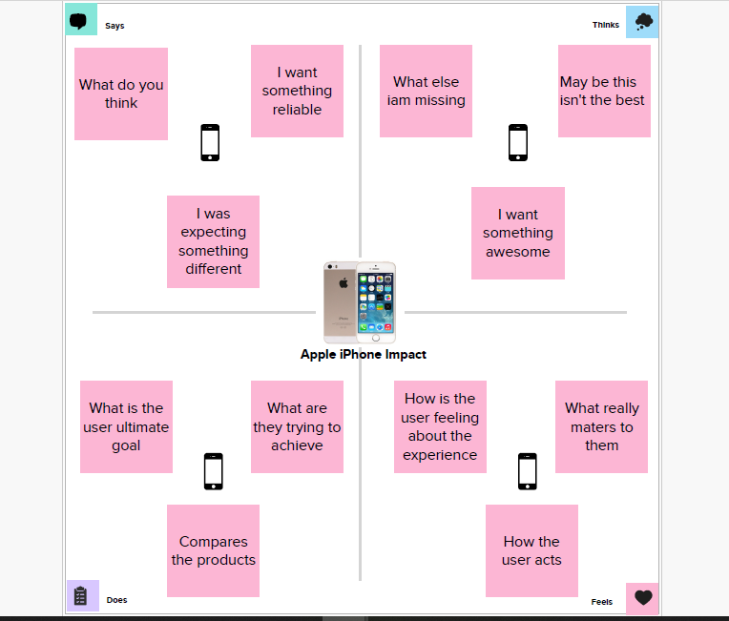

**2.2 Brainstroming Map**

When brainstorming, or attempting to see a particular topic from all angles, linear tools — like lists — aren’t always the best solution. In fact, thinking this way can hinder creativity. The solution? A mind map. This organizational structure allows you to explore a central topic on a deep level through associated ideas and concepts which branch off from the center organically.

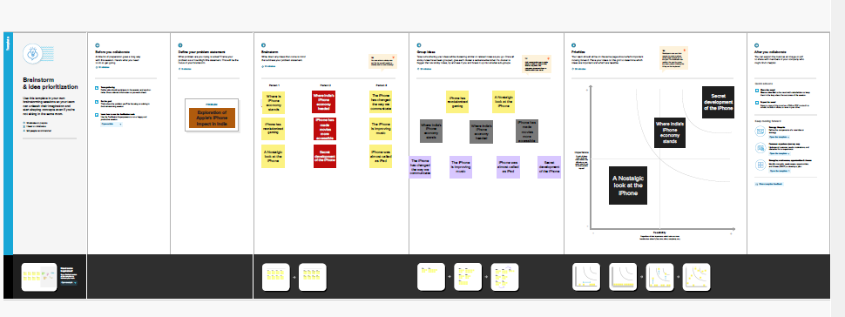

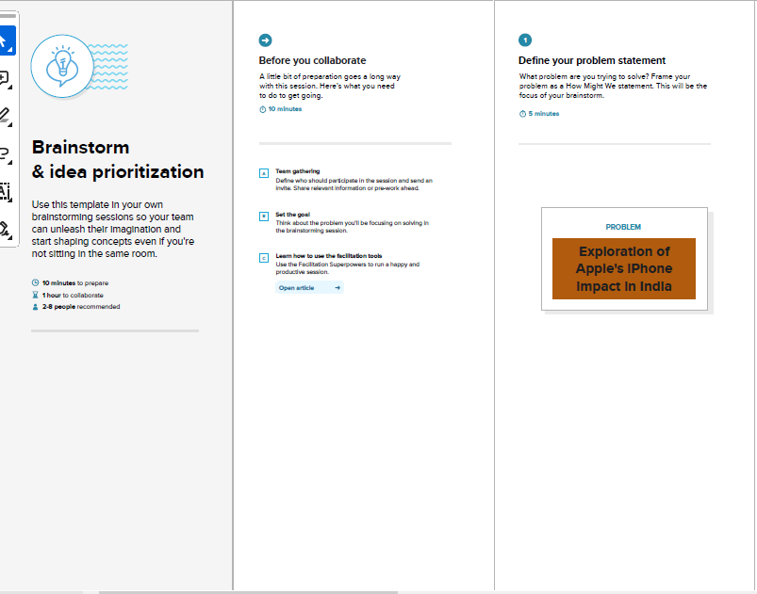

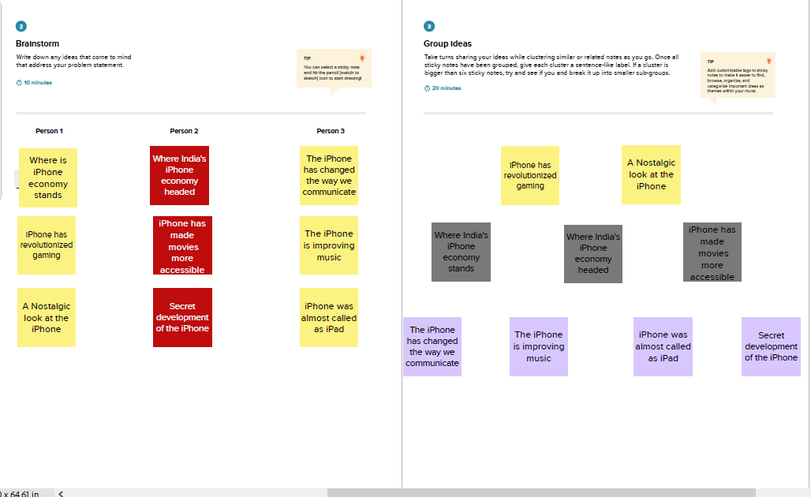

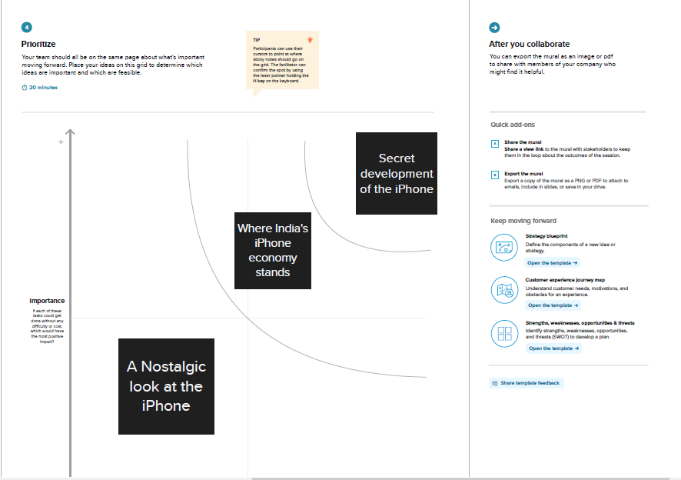

**Result**

This project visualize the impact of Apple iPhone in India. Also many visualizations were made by comparing the iPhone with other brands of android. Here the battery ype, battery specifications also storage of each brands of android were compared and visualized. The dashboard explains the comparison of androids over the years.

**KPI**

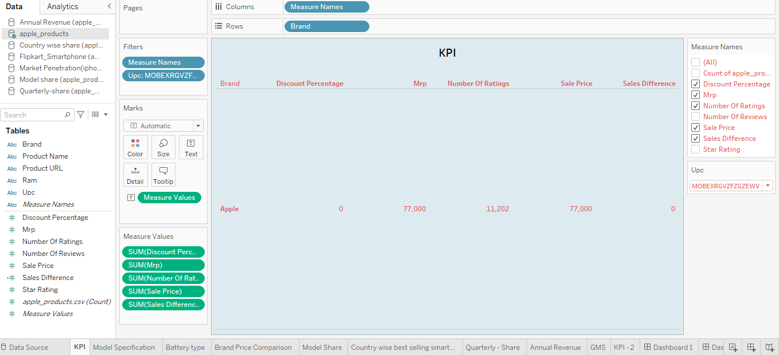

**KPI STORY**

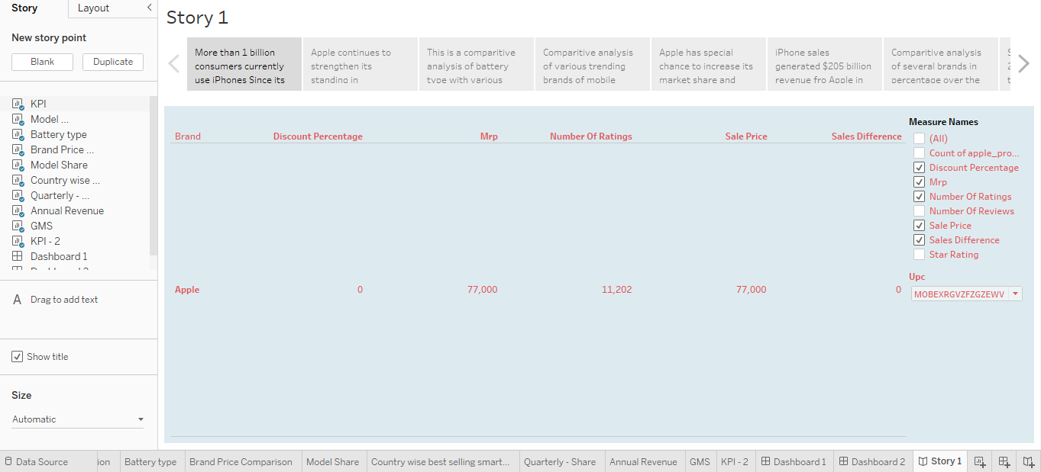

**KPI – 2**

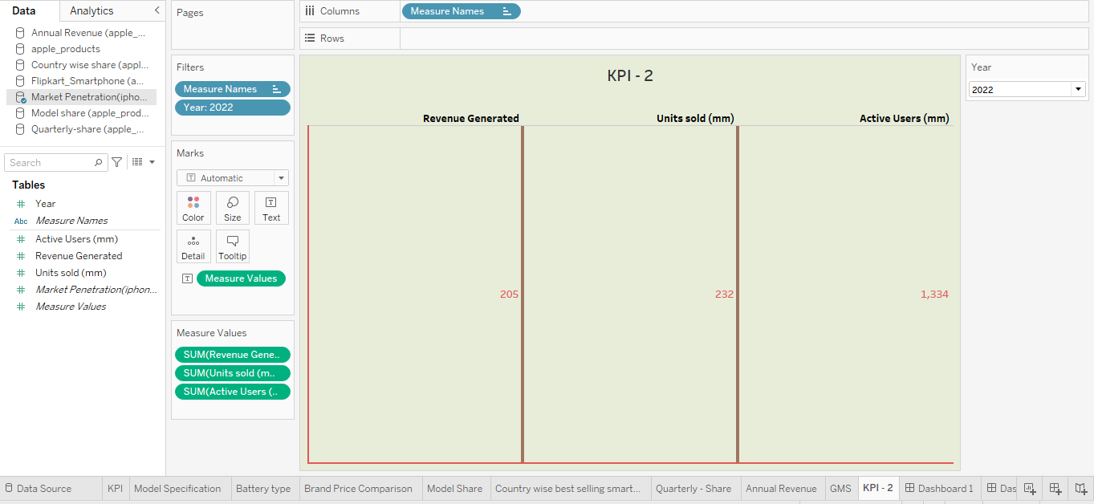

**KPI – 2 STORY**

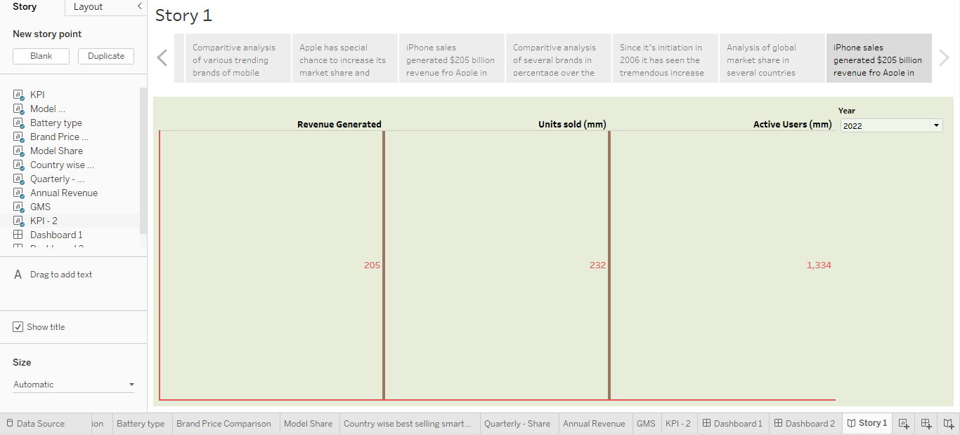

**MODEL SPECIFICATION**

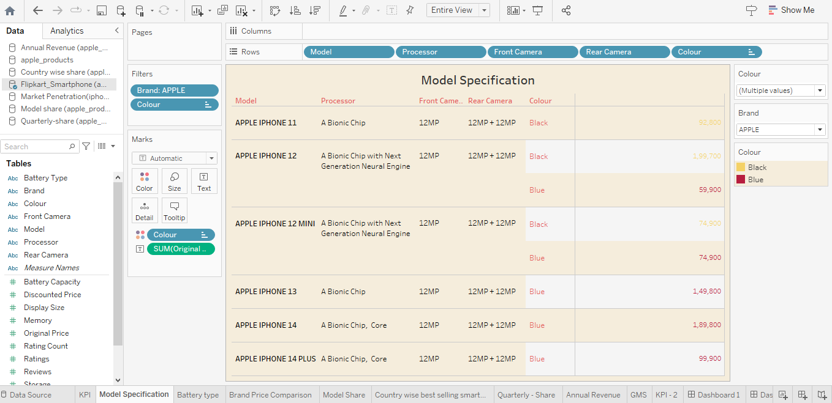

**MODEL SPECIFICATION STORY**

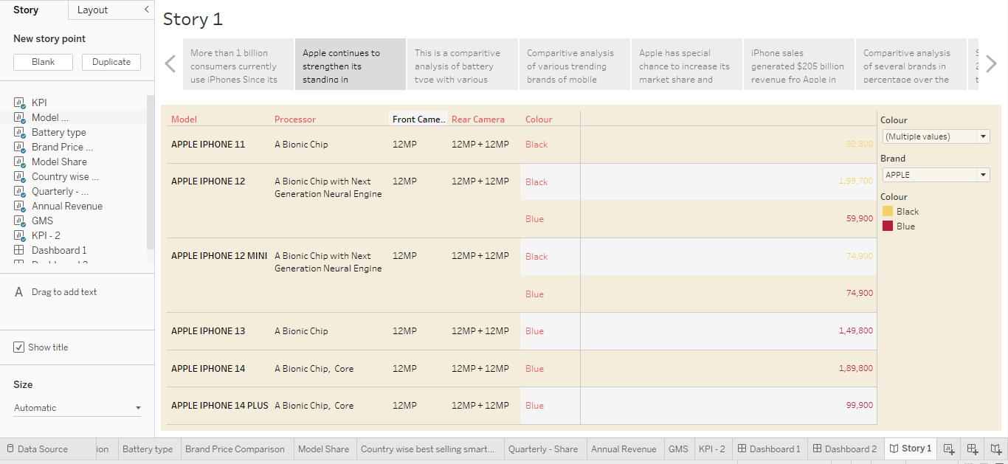

**MODEL SHARE**

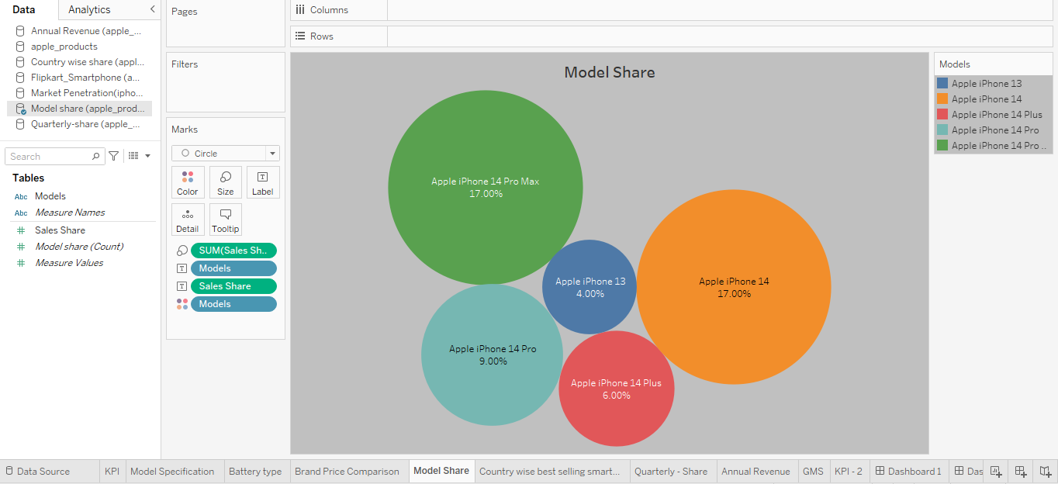

**MODEL SHARE STORY**

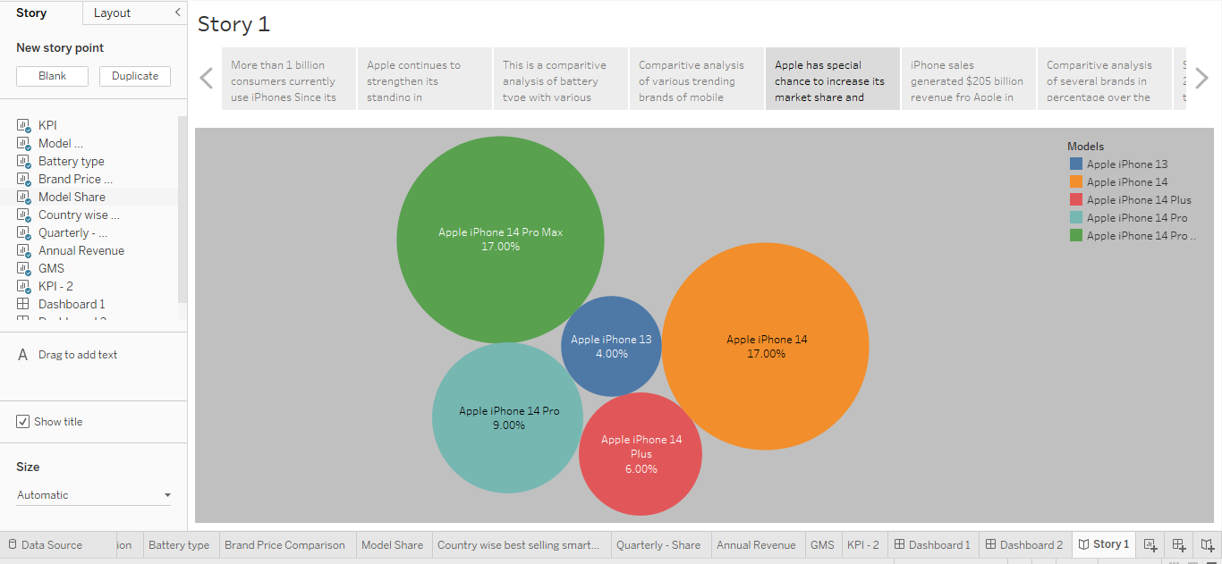

**QUARTERLY SHARE**

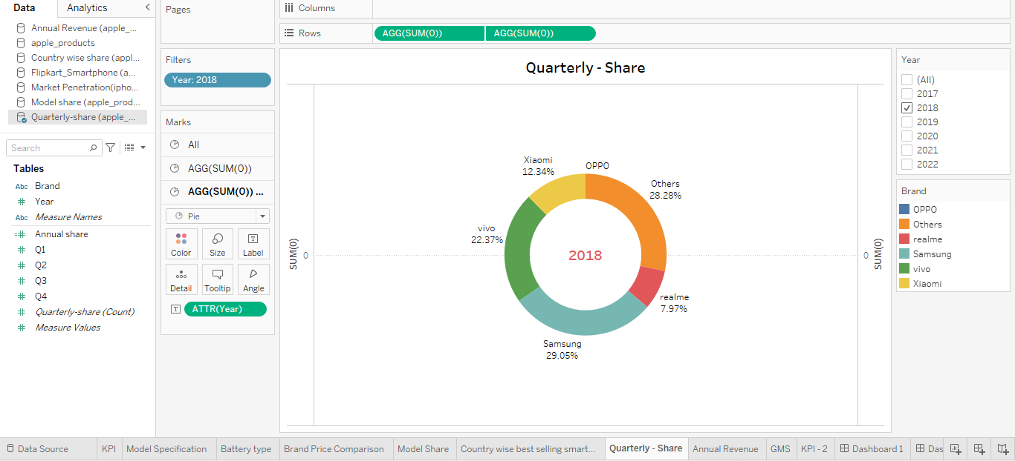

**QUARTERLY SHARE STORY**

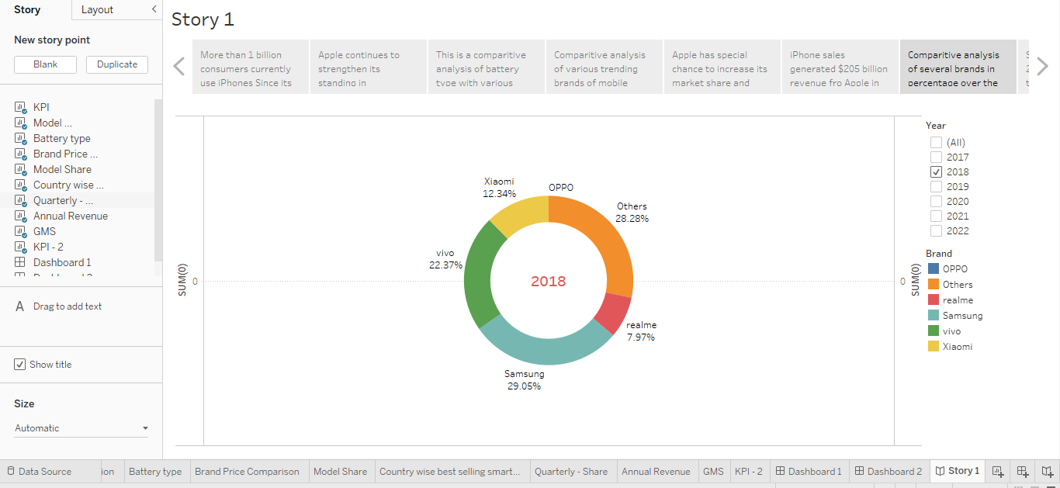

**GLOBAL MARKET SHARE**

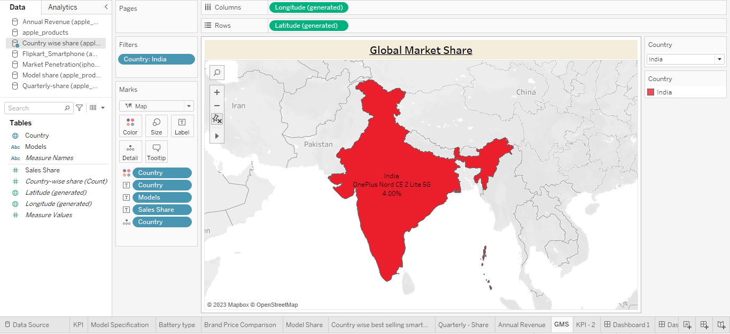

**GLOBAL MARKET SHARE STORY**

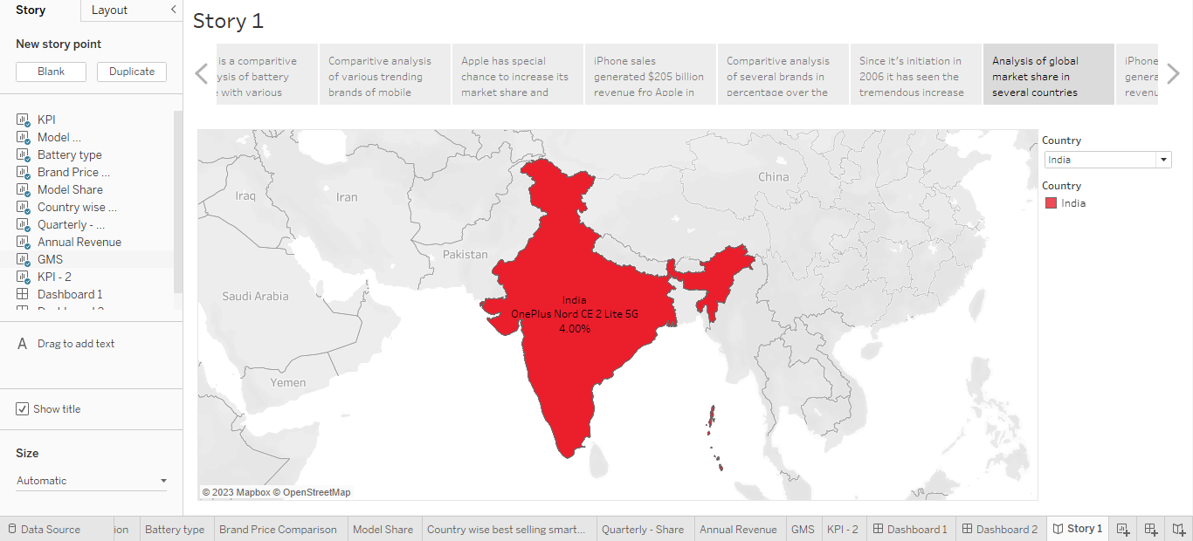

**COUNTRY WISE SHARE**

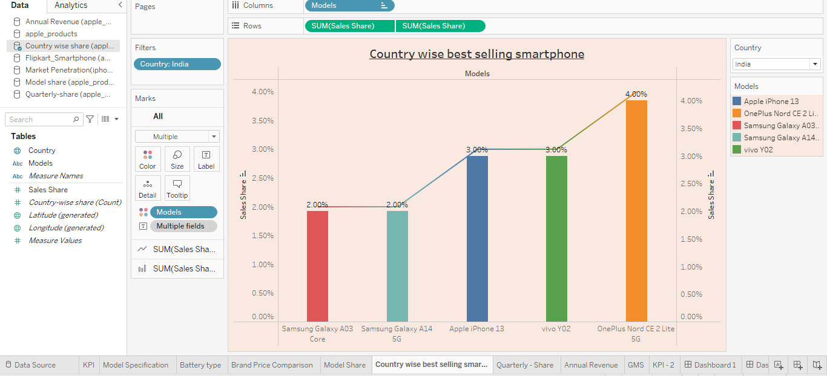

**COUNTRY WISE SHARE STORY**

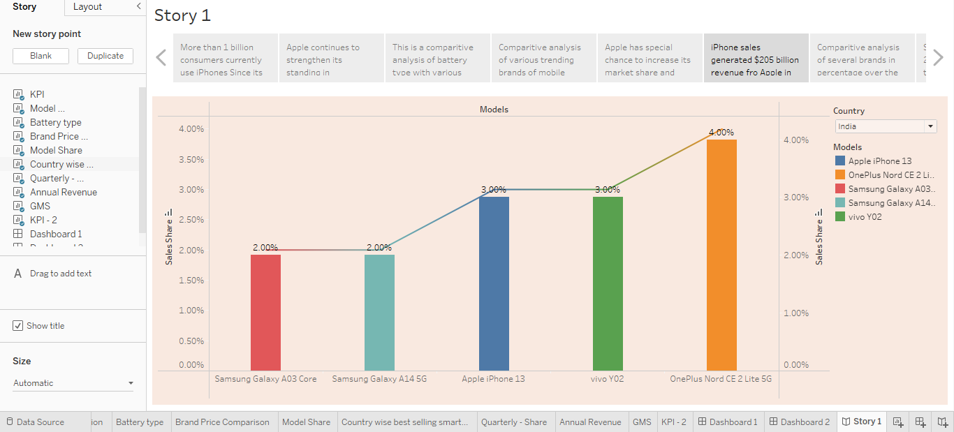

**BATTERY PRICE COMPARISON**

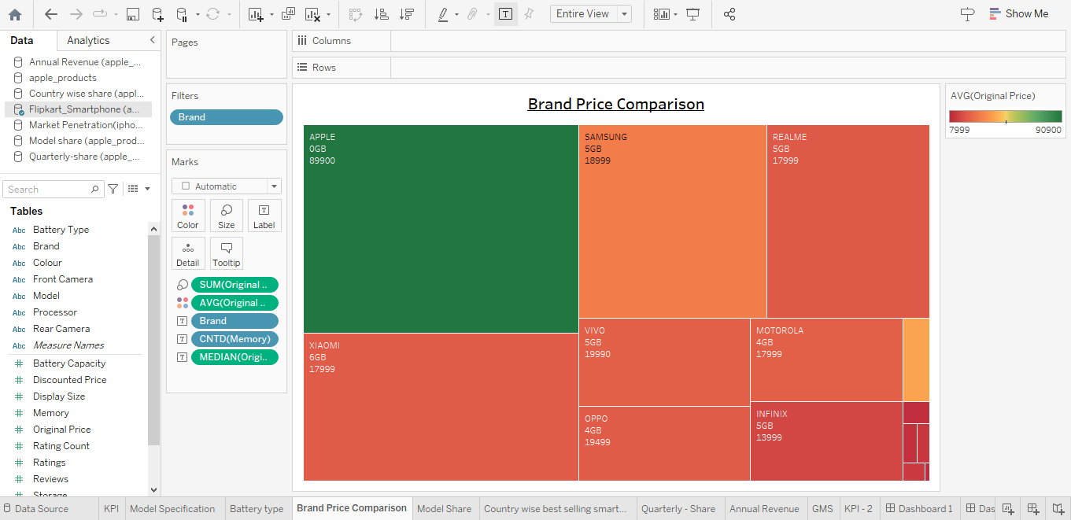

**BATTERY PRICE COMPARISON STORY**

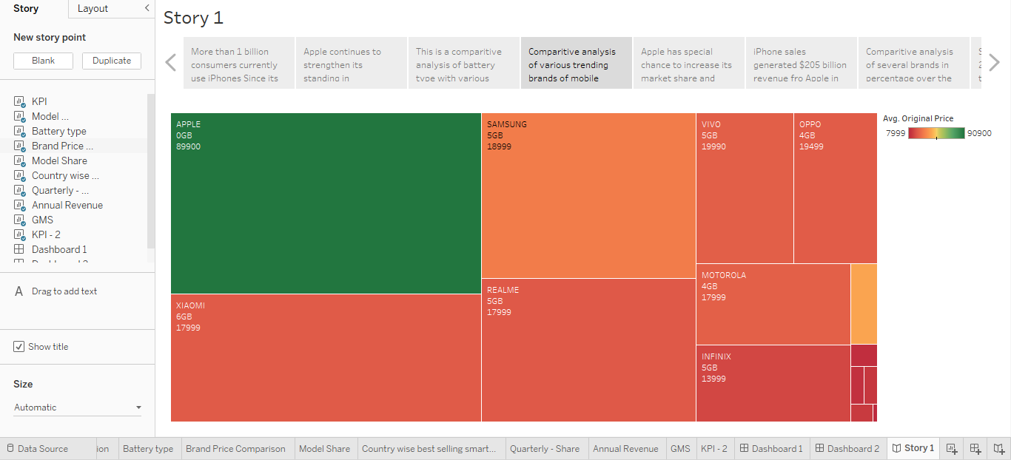

**BATTERY TYPE**

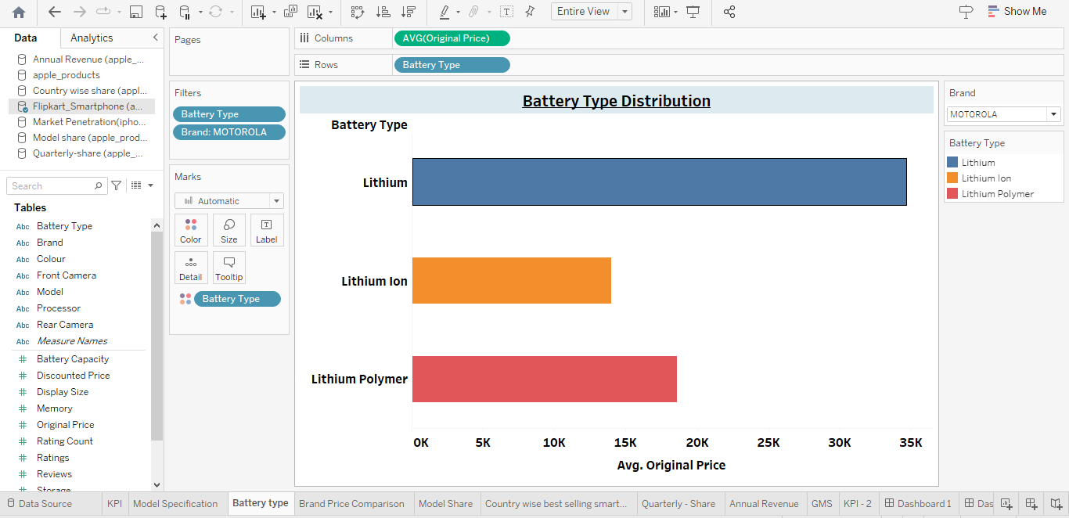

**BATTERY TYPE STORY**

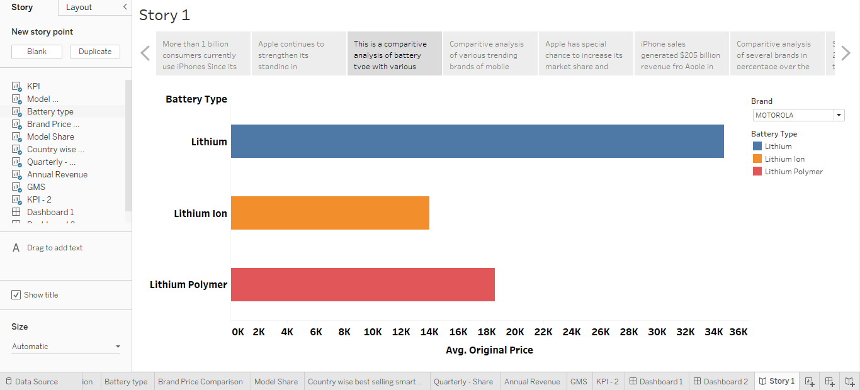

**ANNUAL REVENUE**

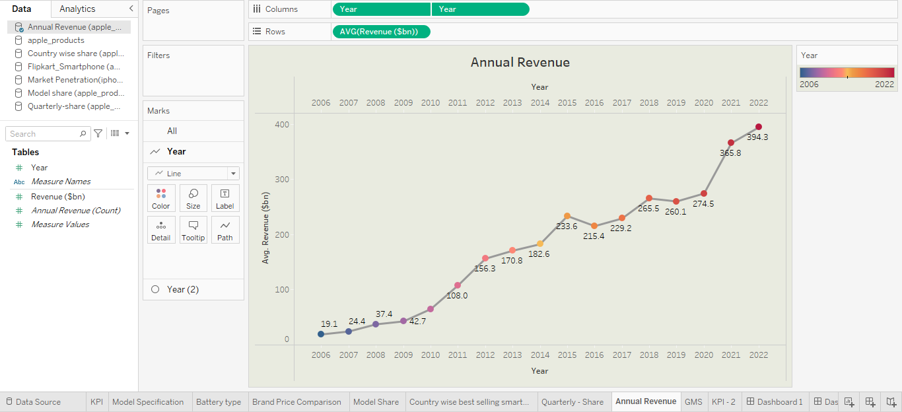

**ANNUAL REVENUE STORY**

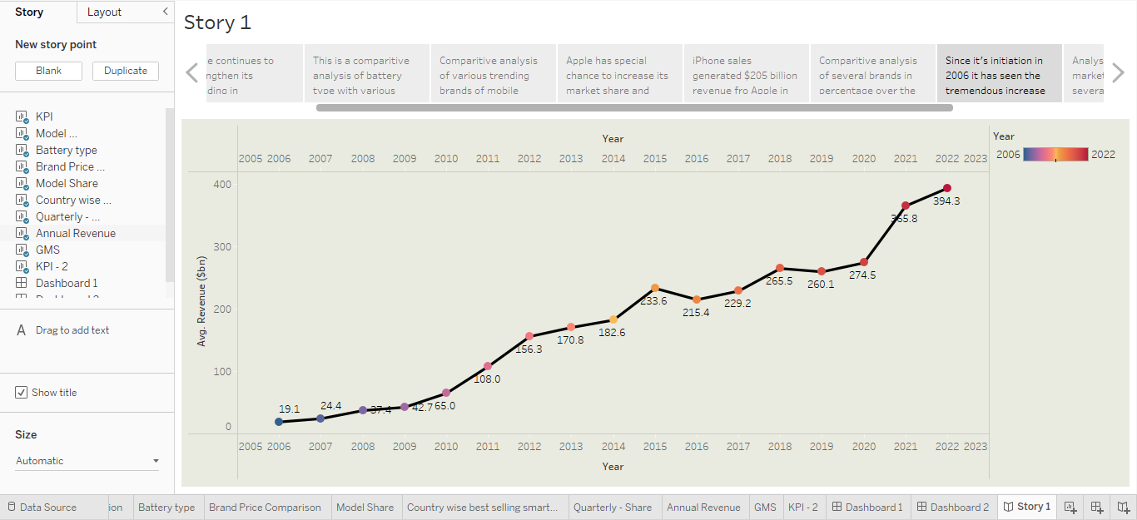

**DASHBOARD - 1**

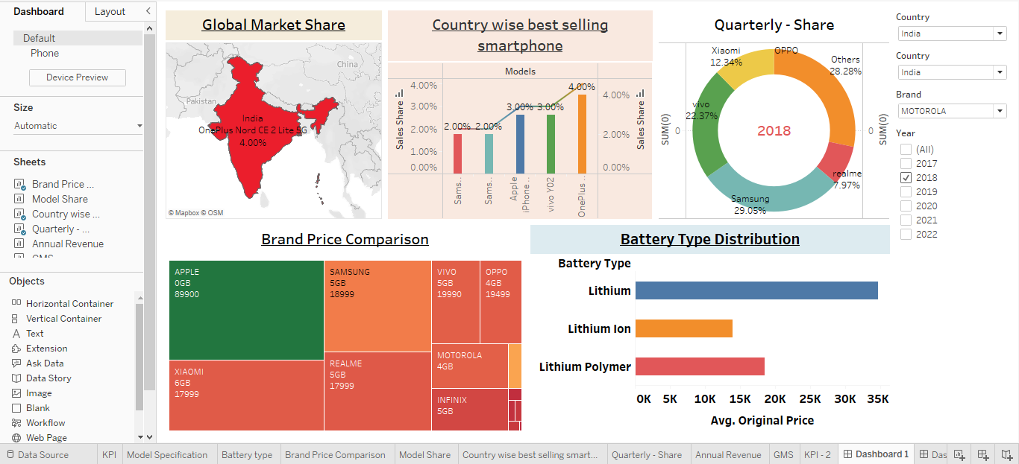

**DASHBOARD – 2**

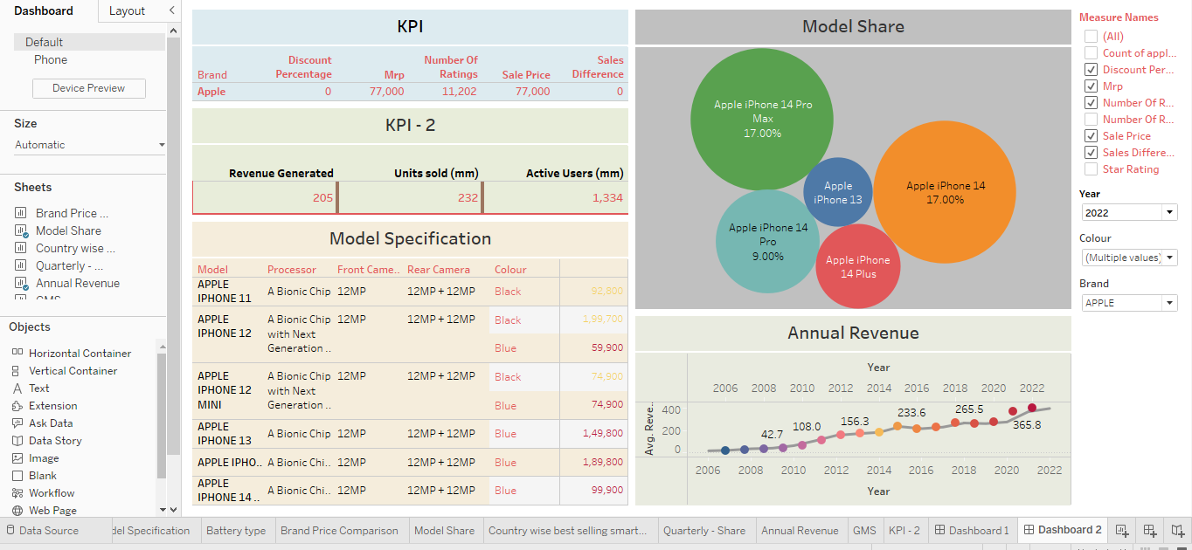

**Advantages & Disadvantages**

**Advantages of the iPhone:**

**1. User-Friendly Interface:** The iPhone has an intuitive user interface that makes it easy to navigate. The touch screen interface is easy to use, and the iPhone’s smooth operating system is simple to learn and use.

**2. High-Quality Display:** The iPhone’s Retina display is one of the best in the market. With a density of over 300ppi, pictures and videos appear clear and crisp. This high-quality display is perfect for streaming TV shows, movies, and graphic-intensive games.

**3. Advanced Camera**: iPhone devices have some of the best cameras in the market. They have been known to produce stunning images and videos of the highest quality. They also come with image stabilization features that help reduce blur and take better pictures in low light.

**4. Apps Ecosystem**: The App Store is unparalleled in terms of access and ease of use. With millions of apps to choose from, users have access to a plethora of tools, games, and services that cater to their needs.

**5. Seamless Integration with other Apple devices**: The iPhone has a seamless integration with other Apple devices such as MacBook, iPad, and Apple Watch. It allows users to access and transfer data across multiple devices.

**Disadvantages of the iPhone:**

**1. Cost:** The iPhone is one of the most expensive smartphones on the market. High-end models can cost over $1000, which makes it a luxury item for many people.

**2. Non-Removable Battery**: The iPhone’s batteries are non-removable, which means that users cannot replace them. This can be a disadvantage for people who rely heavily on their phones and have to replace them regularly.

**3. Limited Customization**: One of the disadvantages of the iPhone is that it has limited customization options. Unlike Android devices, users cannot customize their phone’s interface, which can be a disadvantage for some people.

**4. No Expandable Storage**: Another disadvantage of the iPhone is that it has no expandable storage options. Users have to purchase iPhones with larger storage capacities, which can be costly.

**5. Frailty**: The iPhone is known to be fragile and prone to breaking if dropped. Many users have reported cracking or shattering their screens after accidentally dropping their devices.

In conclusion, the iPhone has been a game-changer in the technological world. It has revolutionized the way people communicate and access information. However, its advantages and disadvantages must be weighed carefully by potential buyers. Ultimately, the choice of whether to purchase an iPhone depends on the user’s preference, needs, and budget.

**Applications**

Apps are the foundation of the mobile economy. Since the arrival of the iPhone in 2007 and the App Store in 2008, apps have become the principal way users have tapped into the smartphone revolution. Applications have helped create a number of multi-billion dollar industries. For example, mobile games now generate over $30bn in revenue per year, while apps from social media companies such as Facebook massively contribute to their multi-billion dollar revenues each quarter. This massive rise in popularity has had a knock-on effect for [advertisers](https://www.adjust.com/glossary/advertiser/). Their widespread use has made it increasingly important for companies to use mobile as a key advertising channel. Whether companies are generating business through apps or advertising on mobile devices, applications have made mobile advertising a valuable industry on a global scale.

Mobile applications are also important due to their versatility. The most popular app verticals include:

* Entertainment & News (for example, an application created by The New York Times, Youtube or Netflix)
* Travel (flights, hotels)
* Gaming (Mid-core games, hyper-casual games)
* Social (for example, Facebook Messenger, Reddit and Twitter)
* Business and Finance/Fintech (online banking such as PayPal)
* Utilities (such as Google Translate, Find My Device)
* Health & Fitness (for example, meditation app Headspace, Sleepcycle and food education apps)
* E-commerce (from eBay to Amazon, and everything in-between)

**Conclusion**

The main conclusion that can be drawn is we found to be the most interesting about Apple is how they are very innovative and early adapters. Apple is usually the first company to come out with a new product line before anyone else. This is very risky but it seems to be working to Apple advantage. This shows that taking risks can sometimes make or break you and Apple has great potential and has a lot to improve. Currently, Apple is demonstrating negative aspects of TNCs, contributing to international debt crisis through exploitation of workers. In a way, Apple is promoting debt crisis in LDCs by accessing their labour and raw materials on the cheapest possible terms. If it is willing to play the role of a beneficial TNC, the global economy can certainly benefit. Furthermore, people in the least developed countries, and the environment, will benefit as well. This requires a change from all stakeholders: the company itself, the consumers, the shareholders, and the workers. It is important for a TNC to progress towards beneficial behaviour because this can determine people's view on progressing towards further globalization, as influenced by neoliberalism.

The insight obtained from consumer behaviour research is critical in the development of effective cognitive marketing strategies that resonate with the target audience. An understanding of how consumers interpret marketing strategies, the consumer integration process, and activation of product knowledge result in critical insight for Apple. Apple uses this insight to market its products and retain their competitive advantage in the marketplace. The consumer research Apple conducts related to cognition provides an understanding of how the target audience acquires and stores memory along with other important memory factors such as shopping scripts or product schemas. The types of knowledge (general or procedural) that the different marketing strategies and tactics activate are also important elements that influence marketing strategy.

The company occupies a certain cognition based on Apple creating a context for their products focused on developing an eye-catching, simple design, and ease of use for complex

technologies resulting in significant benefits for the consumer. Apple also positions each product emphasizing its innovations and communicating differentiated benefits to its consumers effectively.

**Future Scope**

Swift is one of the greatest positives in iOS mobile development. The foundation of app development is the programming language, and if that is not strong, it isn't likely to be a successful one, either. Swift is a well-known programming language widely accepted and widely used by iOS application developers of every size and background. The language can fulfill its promise to deliver outstanding results with no coding. In addition, it is an effective communication tool between the coder and the computer, making it easier for computers to comprehend the requirements.

###### **1. Emulators of high quality create an iOS application development experience that is amazing**

Emulators make the entire process of developing mobile apps easier and assist in creating experiences that keep users interested. This is why the overall quality of emulators is of utmost importance. Compared to different operating systems, iOS emulators tend to be more efficient and provide excellent support. This is what makes iOS emulators superior, aiding developers to speed up the process of developing apps and making them simpler.

###### **2. It's quicker to develop an iOS application.**

Studies discovered that iOS apps require 30-45% less time than Android apps. One of the reasons this is because creating code specifically for iOS applications is simpler. As we mentioned in the article, Swift makes it simple to create iOS applications instead of the coding process for Java written for Android, which can take a significant amount of time.

Another reason it's easier to create iOS applications is that Android is an open-source platform, and there isn't any standardization. This means that more kinds of devices, diverse components, and software must be addressed. However, Apple is a closed ecosystem, which means there are only some standardized devices and the operating system.

###### **3. Better Developer Support & Tools**

The tools and support for developers that Apple provides to developers Apple is superior to the other operating systems, including one of the top market players - Android. Because it is an open-source platform which means that the Android platform does not have any sort of standardization, which creates a challenge when you are trying to find good support for developers or tools for development, because the focus is much more focused on the area of iOS app development, The support and tools that are available for it are better developed as well.

###### **4. Lesser Fragmentation for iOS devices simplifies the process**

Even a well-developed Android application has a significant probability of encountering bugs due to having to contend with many platforms, brands, and screen dimensions! But, the variety of different versions and devices are restricted in the case of[iOS App Development services](https://www.perfectiongeeks.com/ios-app-development-services), making it simpler to create apps and decreasing the risk of bugs that are not anticipated within the application.

###### **5. If you are looking to make money with your app, you must consider the possibility of customers making purchases on iOS and Android.**

Android users are generally less inclined to spend money on their apps and are generally speaking, not huge users. This is why, on Android, the[Android platform](https://www.perfectiongeeks.com/best-android-app-frameworks), free apps with ads in the app are more prevalent. Even though it is only half the amount of downloading, Apple App Store generates twice the revenue as Google Play. Apple customers are more inclined to purchase apps and purchase in-app purchases or spend money on them. However, there is a notable exception in the cases of utility apps, where Android surpasses Apple by a considerable margin.

###### **6. It's simple to keep an app running as long as users keep the OS up-to-date.**

Due to the variety of screens and resolutions for devices, it is challenging to make sure that your application works with your operating system. This is not only the prevention or reduction of crashes and bugs for those still using earlier versions of OS. Android users are more patient with updating their operating systems in terms of statistics. On the other hand, Apple users tend to be more likely to upgrade the operating system.

###### **7. Development Cost**

The budget or cost of any project will depend on its overall size and the degree of complexity. The larger and more complex the project, the greater can be expected to come out of the budget or the cost related to it. As we have discussed in previous sections, due to the difficulty of coding and the vast amount of resolutions that the developer must deal with when it comes to Android app development, the cost of development is bound to be high. Therefore, the development cost for developers is among the most important elements when deciding between Android or iOS application development for mobile devices.

###### **8. User loyalty**

This is an important measure to keep track of when comparing Android development to iOS development. In terms of statistics, iPhone owners are more loyal to Apple than Android users of their devices. A recent study found that 92% of iPhone owners believe that they'll buy Apple devices exclusively. The percentage was 77 % for Samsung and 59 percent for LG, and 56% for Motorola.

## The Future looks bright for iOS Development

These developments in iOS development have brought significant improvements to the way we design and utilize mobile applications. As a result, iOS App Development must keep track of these technological changes to provide a seamless experience for users. IoT, Machine Learning,[Artificial Intelligence](https://www.perfectiongeeks.com/artificial-intelligence-services), and Augmented Reality are just a few of the latest technologies on which they can improve their knowledge. It's clear it's all going to be with a rosy smile for iOS, and we can expect to see many more exciting innovations from Apple.

If you're in search of someone to be an iOS developer who (a) knows about these developments, (b) is technically proficient, and has the skills to create an iOS application, We've got some excellent new news. At Full Scale, we rely on our technology experts to create mobile apps that boost the bottom lines. Additionally, we have an entire staff of project management and web designers, and content writers who can deliver the most comprehensive results for your company. Therefore,[Contact Perfection Geeks Technologies](https://www.perfectiongeeks.com/contact) to begin working on your software development project.

**Appendix**

**Empathy Map & Brainstroming Link**

<https://github.com/asmsu105msu10520211051510203/Apple-iPhone-impact-in-India_NM2023TMID06422>

**Dashboard – 1 Link**

<https://public.tableau.com/views/iPhoneImpactinIndia-Dashboard1/Dashboard1?:language=en-US&publish=yes&:display_count=n&:origin=viz_share_link>

**Dashboard – 2 Link**

<https://public.tableau.com/views/iPhoneImpactinIndia-Dashboard2/Dashboard2?:language=en-US&publish=yes&:display_count=n&:origin=viz_share_link>

**Story Link**

<https://public.tableau.com/views/iPhoneImpactinIndia-Story/Story1?:language=en-US&publish=yes&:display_count=n&:origin=viz_share_link>

**Video Demonstration Link**

[**https://drive.google.com/file/d/1KEwTNrtR4L9KNRkvpwpPc7pv3iKCyu9_/view?usp=sharing**](https://drive.google.com/file/d/1KEwTNrtR4L9KNRkvpwpPc7pv3iKCyu9_/view?usp=sharing)